<https://citibikenyc.com/how-it-works>

* [How it Works](https://citibikenyc.com/how-it-works)
* [Pricing](https://citibikenyc.com/pricing)
* [Find a Bike](https://account.citibikenyc.com/map)
* [Explore NYC](https://citibikenyc.com/explore)
* [Reduced Fares](https://citibikenyc.com/community-programs/reducedfare)

[Log In**Join**](https://account.citibikenyc.com/login)

# Experience NYC in a whole new way

Citi Bike is the nation's largest bike share program, with 25,000 bikes and over 1,500 stations across Manhattan, Brooklyn, Queens, the Bronx, Jersey City and Hoboken.

[**Get the app**](https://citibikenyc.com/how-it-works/app)

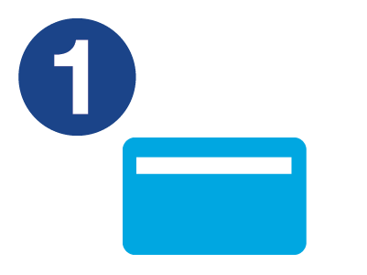

## Join

Become an Annual Member or buy a short-term pass through the [Citi Bike app](http://app.citibikenyc.com/S6Lr/xsceUjcYOF).

[See prices](https://www.citibikenyc.com/pricing)

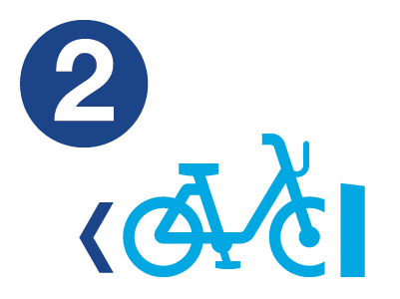

## Unlock

Find an available bike nearby, and get a ride code or use your member key to unlock it.

[Find a bike](https://member.citibikenyc.com/map/)

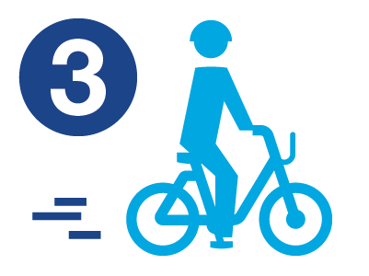

## Ride

Take as many short rides as you want while your pass or membership is active.

[See popular rides](https://www.citibikenyc.com/explore/popular-rides)

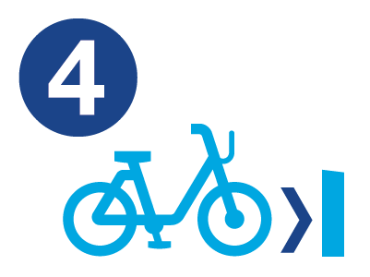

## Return

Return your bike to any station, and wait for the green light on the dock to make sure it's locked.

[Get started](https://www.citibikenyc.com/pricing)

## Why Citi Bike?

### Save Money

Using Citi Bike can save a lot of money over taking taxis. And a whole year of Citi Bike costs less than two monthly subway passes!

[**Learn More**](https://citibikenyc.com/pricing)

### Save Time

Citi Bike is often faster than other modes of transportation (especially when going crosstown), and it's more convenient than owning a bike.

[**Join Today**](https://citibikenyc.com/pricing)

### Have Fun

Whether you’re using Citi Bike to commute to work or ride to meet friends, we bet you’ll get there with a smile on your face.

[**Try it Out**](https://citibikenyc.com/pricing)

### Get Exercise

Getting places by pedal power is great exercise. Even biking short distances can lead to positive health benefits, as well as reduced stress.

[**Find a Bike**](https://member.citibikenyc.com/map/)

### Go Green

Biking saves gasoline, prevents carbon emissions, and keeps pollutants out of the air. It’s not only healthy for you, but also for the environment!

[**Start Riding**](https://citibikenyc.com/pricing)

## Designed with convenience in mind for quick trips, Citi Bike is a fun and affordable way to get around town.

**Rules of the Road**

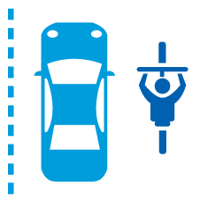

**Ride with the traffic**

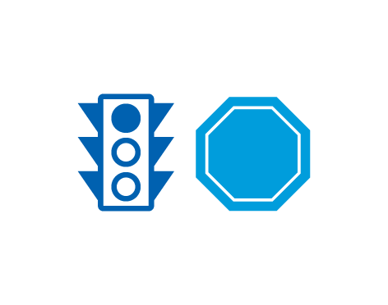

**Obey traffic signals**

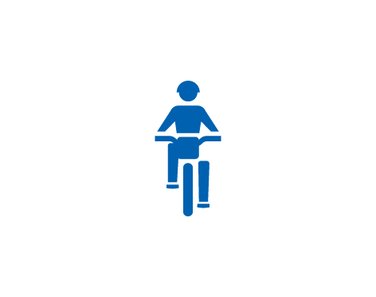

**Stay off the sidewalk**

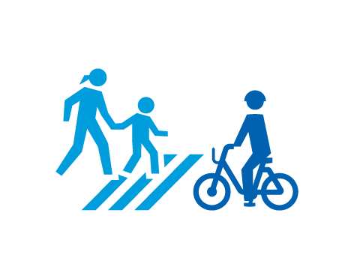

**Yield to pedestrians**

### Get the App

The perfect co-pilot for getting around town.

[**Learn More**](https://www.citibikenyc.com/how-it-works/app)

Explore your city. Access more than 25,000 bikes across 1600 stations.

[**Download to ride**](https://citibikenyc.com/how-it-works/app)

## Find a bike

In the Lyft app or Citi Bike app, enter your destination to plan your ride. Single Rides in the app start at $3.99/trip.

[See prices](https://citibikenyc.com/pricing)

## Unlock

At the bike station, unlock a bike by scanning it’s QR code. Learn more about our [ebikes or classic rides](https://citibikenyc.com/how-it-works/meet-the-bikes).

## Ride

Have the time of your life on two wheels!  
[See popular rides](https://citibikenyc.com/explore/popular-rides)

## Dock bike

Dock your bike at your destination station—wait for the green light.

© Lyft, Inc. 2022  
  
Citi Bike, Citi Bike and Arc Design and the Blue Wave are registered service marks of Citigroup Inc.  
  
We at Citi Bike strive to provide access to our services to all individuals, including through an accessible website. If you have questions, comments, or encounter any difficulty in using this site, please submit feedback via: [citibikenyc.com/accessibility-feedback](https://citibikenyc.com/accessibility-feedback)